

**Honours Project - MHW225671**

**Final Report**

**2020-2021**

**Department of Computing**

**Submitted for the Degree of:**

**BSc Computing**

**Project Title: Developing a chatbot companion**

**Name: Arron Fairley**

**Programme : BSC/BSC (hons) computing**

**Matriculation Number: S1918040**

**Project Supervisor: Tianfield Huaglory**

**Second Marker:**

**Word Count: 9903**(***excluding contents pages, figures, tables, references and Appendices***)

**“Except where explicitly stated, all work in this report, including the appendices, is my own original work and has not been submitted elsewhere in fulfilment of the requirement of this or any other award”**

**Signed by Student: Arron Fairley Date: 21/03/2021**

Contents

Abstract 6

1 Introduction 6

1.2 Project Background 6

1.3 Project outline 9

1.3.1 Primary aim 9

1.4 Research Objectives 9

1.4.1 (rO1) Gather requirements and functionality 9

1.4.2 (rO2) Create a test plan for the AI 9

1.4.3 (rO3) Implementation phase 1(Prototype) 9

1.4.4 (rO4) Implementation phase 2 (integration phase) 10

1.4.5 (rO5) Obtain focus group 10

1.4.6 (rO6) Commence user testing 10

1.4.7 (rO7Evaluate and conclusion 10

1.5 Hypotheses 10

2 Literature and Technology Review - UPDATE 11

2.1 Investigate the Azure Bot Service in AI creation 11

2.1.1 Investigate the uses of The Azure Bot Service 11

2.2 Investigate the Bot Framework SDK 11

2.2.1 Features of the SDK 11

2.2.3 Implementation of the SDK 12

2.3 Investigate deploy methods 13

2.3.1 Deploying with Azure ARM templates 13

2.4 Investigate What a chatbot is 13

2.4.1 Investigate the different types of chatbot 13

2.4.2 Investigate chatbot “channels” 13

2.5 Investigate what an NLP tool is 14

2.5.1 Investigate what QnA is 14

2.6 Previous companions 14

2.6.1 Issues with previous companions 14

3. Problem analysis 15

3.1 The Agile approach 15

3.2 Execution Steps 16

3.2.1 Requirements 16

3.2.2 Design 16

3.2.3 Implementation 16

3.2.4 Testing 16

3.2.5 Evaluation 16

3.2.6 Discussion 16

3.2.7 Conclusion 16

3.2.8 Further Work 16

4 Requirements 17

4.1 Assessing the literature and technology review 17

4.2 Analysing the hypothesis 17

4.3 Prototype requirements 17

4.4 Phase 2 Requirements 18

4.5 Questionnaire requirements 18

4.6 Ethical requirements 18

4.7 Further Functionality 18

5 Design 19

5.1 Phase 1 19

5.1.1 Architecture Design 19

5.1.2 Functionality Design 20

5.2 Phase 2 21

5.2.1Architecture Design 21

5.2.2 Functionality Design 22

5.2.3 Conversation Flows 23

Gmail 23

Emotion Support 24

Weather Info 25

5.2.4 Questionnaire Design 26

5.2.5 User interface Design 26

6 Implementation 27

6.1 Phase 1 implement 27

6.1.1 Connect to azure 27

6.1.2 Basic communication 30

6.2 Phase 2 implement 31

6.2.1 Connect to QnA 31

6.2.3 Further Functionality 37

6.3 Facebook Implementation 39

6.4 Questionnaire implement 42

7 Testing 45

7.1 Phase 1 Test 45

7.1.1 Test ID 1 46

7.1.2 Test ID 1.1 47

7.2 Basic communication 48

7.2.1 Test ID 2 and 2.4 48

7.2.2 Test ID 2.2 and 2.3 49

7.3 Phase 2 test 49

7.3.1 Test Id 3 50

7.4 Further Functionality 50

Test ID 4 52

Test ID 4.1 52

Test ID 4.2 53

Test ID 4.3 53

7.5 Facebook test 53

Test Id 5 54

7.6 User test (questionnaire) 54

8 Evaluation/Discussion 56

8.1 Phase 1 Evaluation 56

8.2 Phase 2 Evaluation 56

8.3 Questionnaire Evaluation 56

8.4 Hypothesis Evaluation 56

8.5 Agile Evaluation 57

9 Ethical and Professional Issues 58

10 Conclusions 58

10.1 Project Resume 58

10.2 Final Conclusion 59

10.3 Further work 62

Speech recognition 62

Facial recognition 62

Improve triggers 62

11 References 64

12 Appendices 65

Appendix A – Functional Requirements 65

Appendix B – Github repository 67

QnA KBs 67

Source Code 67

Questionnaire results 67

# Abstract

This document details in depth all the stages involved in the creation of this honours project. The application created was designed to combat loneliness in individuals living alone through the creation of a chatbot. After the development of the chatbot was then tested with a fucus group and the results were evaluated and a conclusion was drawn on the effectiveness. Firstly, a Literature and technology review which has been updated had been carried out in order to gain further knowledge into the area of design and implementation of chatbots. This was also to gain requirements that was needed for the chatbot to meet. The implementation of the chatbot was split into 3 separate phases, a prototype with basic functionality created with the Azure bot framework, an advanced state building on top of the prototype using QnA and customised questioning. After which the final phase was the chatbot being connected to the live “channel” in this case, messenger. The main testing processes were by using the chatbot emulator running on a “localhost”. Custom triggers were tested individually and debugging messages were used to analyse validity of said trigger. Unit testing was also carried out at various stages to handle errors as they occurred allowing for a “cleaner” build. This project used an Agile approach allowing for more flexibility between different aspects of the creation of the project. As a further testing method the chatbot was then tested against a live focus group who tested the functionality of the chatbot independently. After the focus group had tested the chatbot a questionnaire was then sent to the users which provided overall positive responses with some creative criticism that would be recommended for “future work”. The overall evaluation and conclusion sees the project meeting the project aim and hypothesis.

# 1 Introduction

The introduction section in this report includes a project background in which the main topic of the project and its focus area are discussed and analysed. The project outline and research question describes the purpose of the project and what it aims to achieve in the form of the research question. After which a hypothesis is then given to further understand the intended outcome of this project and how this will be managed.

## 1.2 Project Background

Loneliness can be a very severe and serious issue to some people as it can cause many unwanted side effects and mental issues. Loneliness in people living alone should not be taken lightly and some cases of loneliness, the individual will even resort to suicide (Valtora, 2016). The mental health conditions of people living alone have also been seen to be worse than those who do not live alone. The mental disorders that are living alone are also more severe than those who are not living alone (Holt-Lunstad, 2010).

It has been shown that if an individual is lonely for a long period of time that this could actually half their life expectancy by half. It has even been compared to people that are heavy smokers or those who are majorly obese. (Holt-Lunstad, 2010). This can translate into serious health risks and conditions such as strokes, higher blood pressure and heart attack rates. These will become more severe as the time progresses. (Louiese, 2010). This loneliness will also reduce the body’s immune system making it more likely to catch viruses and other dangerous viruses. If an individual in this state was to become this way, it would be very difficult to overcome the illness that was affecting them. (Mayo, 2020)

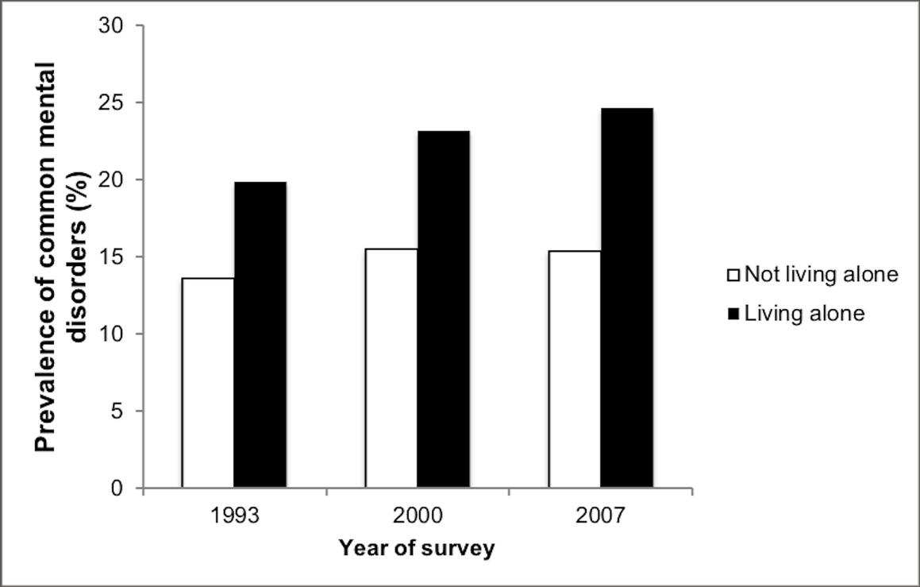

Figure 1Prevalence of common mental disorders (Luis, Jacob, 2019)

There is some organisations that are there for people living alone. However, these services are often limited in availability and the waiting times can be very long for someone that could be living alone already (Kime, 2012). These waiting times can take up to 10 weeks to be able to be allocated a befriender. This could mean that the individual could be suffering through this time. Any mental issues or physical effects of loneliness that the individual could become worse in this time (Abel, 1996). The main issue involved with this style of companionship is not that It can take up to 10 weeks to obtain a companion. It is that most services will only send out the companion once a week and only for an hour (Balloch, 2007). This could mean that the individual wouldn’t be getting enough care that was needed and the purpose of the befriending scheme would be mute.

The samaritans are another organisation that are there to help anyone going through emotional distress. However, this organisation’s focus is not on companionship. Rather it focuses on the prevention of suicides. (samaritans, 2020) The samaritans do work with some befriending schemes but as stated before the help is very limited and often takes a long time to get any concrete help.

There is a form of therapy that is used for those who are lonely. This is called animal assisted therapy. This therapy has been known to have very positive results for the individual in the short term. There is evidence that someone that has access to this type of therapy has lowered levels of blood pressure and cholesterol (cdc, 2017). There is organisation’s that do carry out these services. However, seeing as the government does not have any existing schemes to enable animal assisted therapy. This means that these organisations charge the user to have these services (PAWS, 2020). Another major issue with this form of therapy is that the user will only have limited access to the animal. This is because the therapist animal does not reside with the individual going through the therapy. The animal has another owner and the pet just visits the lonely individual. This can cause more harm in the long run as the user is kept between companionship and loneliness. There is no permanent form of companionship in this treatment.

Ai is involved in human life more than one might think. Almost every day an individual will meet AI at some point in their day. There are many different forms of AI. Such as tools for Psychiatrists, there was an AI created to mimic someone that had Schizophrenia and when a test was carried out with 40 psychiatrists between humans and PARRY. The Psychiatrists could only identify 45 percent of the time which statements were PARRY. This is consistent in random guessing percentages (Boden, 2016).

A form of AI companion that is in existence is digital pets. These have been around since 1996. The first form of digital pet was created by Bandai, this was the Tamagotchi. The user would have to care for this digital pet by feeding, cleaning and dressing the pet. The Tamagotchi could even get sick and “die” if the user did not care for it (Dann, 2019). The Tamagotchi was quite useful for combating loneliness in the sense that the user could become occupied with caring for this digital pet that would always be there for the user. However, the Tamagotchi cannot hold conversation and connect with the user on a social level. This could be an issue for someone who needs human interaction.

Moving on to the next level of companionship we have another form of companionship. This is a form of advanced interactive robot. This robot is called PARO. This companion is in the form of a baby harp seal. The companion is classed as a level 2 medical device and is used for those who may suffer from dementia (Angela, 2015). This companion will respond to tactile inputs from the user and aim to create movements and sounds (in relation to a baby seal) that comfort and soothe the user’s anxiety. This companion moves silently, as to move like it is alive and responds to loudness of sounds also. This makes PARO act like it is alive and remembers patterns that calm the user. PARO will even sleep at night and learn names of its users. The companion will never die and is recharged through a pacifier that plugs into the mouth. This is to create a life-giving connection from the user to PARO (Piore, 2014).

There has been some controversy to this companion as some people view PARO as a danger to the patient’s mental health. The fear that the user will become dependent or further reinforce the bad habits of the user’s mental conditions (Anne, 2010). It is normal for ethical worries to be raised as the line between human and AI companionship begin to blur. The individual views of this type of companion will always be controversial. That is why it is important that the user undergoes a full psychiatric analysis before they are given a PARO to ensure that the user will only obtain positive results from “owning” a PARO. After this the User with dementia will still have a qualified nurse in dementia, to ensure that the companion is helping with the user’s difficulties and not worsening any symptoms (Andrew, 2014)

## 1.3 Project outline

Due to the lack of emotional support chatbots and the ever-rising percentage of mental health issues in people, this project aims to investigate the development of a chatbot that can provide emotional and mental support with conversation using the azure Bot service and the QnA service.

**To develop a chatbot that can provide emotional and mental support with conversation using the azure Bot Service and the QnA service.**

### 1.3.1 Primary aim

The primary aim of this project is to develop a chatbot that can provide emotional and mental support with conversation using the azure Bot Service and the QnA service. Section 1.4 details the objectives required to create this chatbot.

## 1.4 Research Objectives

### 1.4.1 (rO1) Gather requirements and functionality

From reading through the literature and combining it with the project problem statement. Ideas of the types of interactivity the AI will be documented. Documentation will then be created to form the design of the AI. This will include what the functional requirements are. This will set the functional, non-functional requirements and create a specifications document. Conversation flows will be created that will show the type of conversations that will take place. (Ali, 2016)

### 1.4.2 (rO2) Create a test plan for the AI

Once the specifications document is completed, a test plan will be created. This test plan will include the creation of test cases that will be in place for testing the AI’s responsiveness and ensure that the requirements set in the specification document are being met (Baker, 2008). The creation of the Questionnaire to be used after the development of the companion will also be created.

### 1.4.3 (rO3) Implementation phase 1(Prototype)

By using the documents created in the previous stages, this stage will include the basic gestures and responses of the AI. By this stage the AI will be able to handle basic communication. The basic triggers and tools will be created. This will set up for phase 2.

### 1.4.4 (rO4) Implementation phase 2 (integration phase)

The AI will have the full training and once made as robust as possible, will then be integrated into a Facebook profile. Phase 2 will also make use of the NLP tool QnA. This will ensure that the user will be able to connect to the AI companion at any time through Facebook and will also have a more positive and interactive experience thanks to Qna.

### 1.4.5 (rO5) Obtain focus group

A group of people will need to be resourced. The group that is resourced will be briefed on what the Companions purpose and the purpose of the test being carried out is. This will be in order to carry out some further testing once the companion has been fully developed. An initial questionnaire will be provided to set a control, asking the tester questions in areas such as loneliness and intensity. Negative feelings due to being alone etc.

### 1.4.6 (rO6) Commence user testing

The users will then be asked to use the companion at least once a day. After this test period the test group will then be given the questionnaire again to see if the companion has helped in any of the aspects that were stated.

### 1.4.7 (rO7Evaluate and conclusion

After the test period and questionnaires have been completed. The test results will be combined and compared. An evaluation of the results will be created and a conclusion of the effectiveness in these areas and as an overall will be created.

# 1.5 Hypotheses

The created chatbot will be able to have conversation with the user and provide emotional and mental support.

# 2 Literature and Technology Review - UPDATE

This is an updated version of the technology review with the addition of an overview on chatbots and the various uses that can be applied to a chatbot. It also now includes more reviewing on the NLP tools and how they will be useful to the project. This review was used to further streamline the objectives and methods used to create the project.

## 2.1 Investigate the Azure Bot Service in AI creation

Seeing as the companion will be implemented using the Azure bot service. It would be beneficial to investigate further into the different uses and features to further understand how to implement this project.

### 2.1.1 Investigate the uses of The Azure Bot Service

The Azure bot service is a comprehensive bot creation tool that allows highly customisable AI. The service implements the Bot framework SDK to enable a natural language processing tool (QnA) to hold natural conversations with the user. This will be useful for this project as the main purpose of this project is to create a companion that will be able to relate to the user. (ashish, 2018)

This service handles deployment also by using the azure cloud and ARM templates, that will be covered later in this report. This makes the bot “live” and allows for final testing before connecting to a “channel”, a service such as messenger.

The Azure bot service is also able to connect the completed bot to other channels such as Facebook messenger. This means that testing of the AI could be carried out remotely from clients. This is beneficial to the project as with covid19, it would be difficult to create a test group physically. This means that by using messenger to connect the bot to (microsoft, 2019).The project could still be successfully tested.

The azure bot service also includes many samples and tutorials on how to create, customise, test and publish the bot. This has been very useful in the implementation of the prototype of this project that should be available before “Dec – 14- 2020”. These samples and tutorials that are part of the services has been useful for learning how to develop an AI successfully.

## 2.2 Investigate the Bot Framework SDK

The bot framework SDK is the development Kit that the bot will be implemented in. The framework combined with the services is what will create the functioning AI.

### 2.2.1 Features of the SDK

The SDK supports multiple programming languages that allow for more freedom of what the AI will be created for some supported languages are C#, Java script, Python. The SDK is what the developer uses to create the functionality of the bot. This allows the developer to be able to use QnA which is responsible for the AI understanding Text or video to be able to understand conversation and relate it to a function. With the use of triggers which are input from the user QnA will be able to understand what the user requires or return a statement or in this case a reply to the user.

Once the initial prototype was created which formed the basic functionality of the chat bot. Which meant that the chatbot could handle basic communication. Phase 2 was then executed which handles connecting to the QnA knowledge base that was also created.

### 2.2.3 Implementation of the SDK

Below is an implementation of one of the sample tutorials that enables the user to receive an echo message from the bot. Although basic this example is a good starting point and can easily be adapted and expanded upon. This bot was developed using C#.

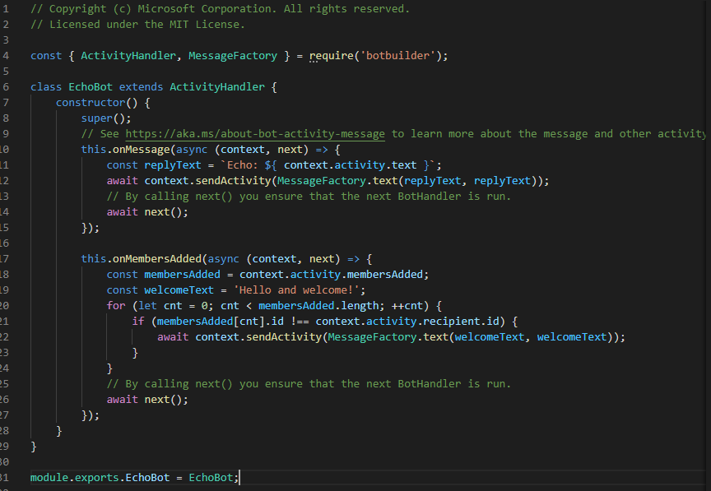

Figure 2-sample bot

The output of the above code shows what the bot would look like.

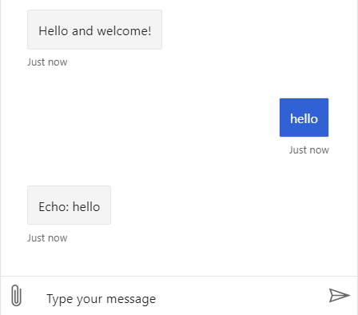

Figure 3 - sample bot testing

## 2.3 Investigate deploy methods

Investigating into deployment methods of the created AI is also important in this project as the completed AI will need to be deployed to a service then connected to a channel. Research into how this will be implemented will be shown in the next section.

### 2.3.1 Deploying with Azure ARM templates

An azure ARM template is essentially a JSON file that allows all the bots data to be deployed up into a live service. With the use of the ARM template the AI will become active and able to be connected through the messenger service. (Microsoft, 2020) The azure bot service includes a detailed tutorial on how to set up an ARM properly.

## 2.4 Investigate What a chatbot is

A chatbot is essentially a piece of software that is developed to assist humans in many different forms. This could be from answering questions from the user. To ordering groceries from a local shop to be delivered. Chatbots have a good standing in businesses where they could be used as a virtual assistant. This means that the need for human resources would be lessened and a client for a business could gain information 24/7 from the chatbot instead of relying on the usual operating times of human assistants. (Pickell, 2019)

### 2.4.1 Investigate the different types of chatbot

In general, there are three different types of chatbot. In this section the three main types of chatbot will be discussed. The first type is the rule based chatbot. This type of chatbot is considered to be the most basic type of chatbot. It is designed to ask questions to the user and then offer answers in a set answer layout in the form of clickable buttons. This type of bot is often very limited in the quality of the service to the user however are also the easiest to build (Crew, 2020). For this reason, it would not be useful for the project as it requires more functionality than this type of bot.

The next type of bot is the intellectually independent bot. This bot would learn from Machine learning. So over time this bot would “learn” phrases of the user and be able to relate to an answer to the users question or phrase. These bots can take time to train and can become unpredictable with what answers or suggestions that may be recommended by the bot. for example if the bot teaches itself to answer a question, however the answer was “wrong” (Crew, 2020). Seeing as this type of bot is so unpredictable. It would not be a good idea to use this type of bot for the project.

The final type of bot would be an AI powered bot. This bot combines the previous types of bots to make a bot that can learn by itself but also have a set of predefined rules to meet the client’s requirements (Crew, 2020) . This type of bot would be most useful to this project as it includes the use of QnA, which is an NLP application and is the more interactive type of bot.

### 2.4.2 Investigate chatbot “channels”

A chatbot channel is what will be used to connect the developed chatbot to a service that the user could use to interact with the chatbot. The channel that is going to be used would be Facebook messenger. The channel connection will be provided by the azure service. This service “normalises” the data going between the client and the bot so that the selected channel (Facebook) can understand the data and transfer it to their chat service. (microsoft, 2019)

## 2.5 Investigate what an NLP tool is

NLP stands for Natural Language Processing. An NLP tool is used to apply AI to the chatbot. This AI will allow for a more natural conversation between the client and the bot. This will be very useful for the project as one of the requirements is to make the conversation to be as natural as possible. Instead of just running off a set of prebuilt rules for the bot to follow. An NLP will be able to understand the meaning of the users question or statement and act appropriately to give a response. (Tell, 2018)

### 2.5.1 Investigate what QnA is

QnA is another type of NLP that will be used for the chatbot. However, this one is used to ensure that the conversational of the chatbot is smother and more human like. QNA will be able to take a question asked by the user and respond with an appropriate answer or prompt to the user with a human behaviour. A knowledge base Is designed or a template one that can be built upon that the bot can refer to for answering such questions. The QnA also has a feature where the responses can be set to a specific demeanour. Such as “caring” which will be utilised in the chatbot. Other options are “professional” and “witty” etc..

## 2.6 Previous companions

The PARO seal was designed to help individuals that are suffering from mental illnesses such as Anxiety, depression and loneliness. It is an animatronic seal that has life like movements and sounds of an actual seal. It was designed so that the patient it was given to would become a companion for the individual. The seal would react to its users tone of voice and physical touches to its head and body.

A study on PARO’s effectiveness was executed and series of tests were carried out. The companion generally had positive results when tested against combating these mental issues. These tests were including Levels of loneliness felt by using a survey that was based off the UCLA Loneliness Scale (Russell, 1996).

### 2.6.1 Issues with previous companions

There are some issues that arise with using PARO. Firstly, it is mentioned that the animal choice may have issues in the companionship. It is generally unusual to have a seal as a pet and it has been mentioned in a study also that a more appropriate animal choice may be something more familiar. Such as a cat or dog. Having a more familiar animal type may increase emotional connectiveness to the companion. (Tkatch, 2020)

The previous mentioned study also declares that there was no control group created. (Tkatch, 2020) This could be a problem as it would mean that the results from the given tests would be difficult to evaluate as there is no baseline to base the tests from. It would have been very beneficial to include a control group.

Although PARO seal received good results it is non-human and as such some individuals may not be able to connect to the animal in the same way they could with a human caregiver. The emotional connection between two humans may be stronger than what an animal may be able to give. This may mean that the individual needs to have a human companion instead of an animal.

The PARO seal is also very expensive with the cost of £5,000 excluding vat (Paro, 2020). This cost may be too much for individuals to pay and would have to look for alternative sources of companionship.

# 3. Problem analysis

The main aim of this project, using a “develop and test” type methodology. Is to develop a chatbot that can provide emotional and mental support and then release it onto Facebook for a focus group to test and answer a questionnaire. From these results an evaluation will be carried out to test if the chatbot satisfies the problem statement/hypothesis.

The projects main aim and requirements were drawn from analysing the literature and technology that was researched. This section will describe the full process of the development of the chatbot including the testing and evaluation stages of the project. The development lifecycle will also be described and as to why it was used.

## 3.1 The Agile approach

Seeing as in section 1.4 requires for multiple prototypes it was concluded that an approach that allows for this would be implemented. The approach used was the agile approach as this allows for multiple prototypes. Another reason Agile was used for this project was to allow for the altercation of the requirements if it was necessary to do so. This made the project easier to accomplish as it was more flexible and allowed for adaptation to any unexpected changes that may have occurred.

Another reason that agile was used over the other available approaches was because agile allows for quick prototyping to happen. This is because the cycles are short compared to a more traditional approach such as the waterfall. (cprime, 2020)

Firstly, the requirements were discovered by use of the literature and technology review. Also, by analysing the hypothesis and main aim of the project. Then the design of the questionnaire and conversation flows were designed before being implemented and tested to see if they met the previously acquired requirements. After the requirements were met phase 2 began and new requirements were drawn up for this phase. The design and development was implemented again and testing was done with a focus group. After which the project was reviewed to see if it met the new requirements.

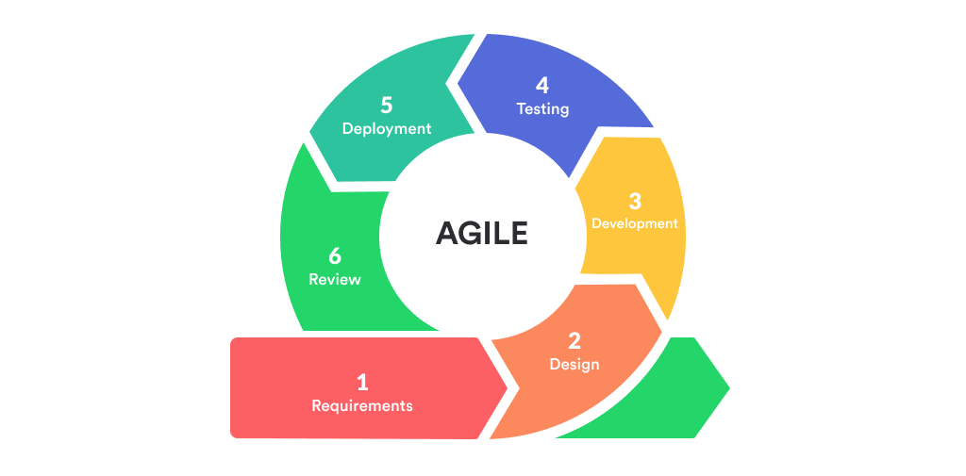

Figure 4 - Agile approach

## 3.2 Execution Steps

This section breaks down the various stages that were involved in the creation of this project. Detailing each stage separately and in depth and explaining why each stage needed to be completed.

### 3.2.1 Requirements

The requirements stage was where the requirements necessary to accomplish the main focus of the project were realised. Because there are 2 phases to the project, the requirements were split into phase 1 and 2. This made the project more manageable as is broke it down into smaller chunks. The requirements were sourced from the literature/technology review and analysing the hypothesis/research question and pulling the functionality needed from that with key words.

### 3.2.2 Design

The project did not have any need for user interface design as the tools and Facebook being used, already had their own interfaces. However, the design of the architecture, conversation flows and use cases were used to simplify the overall flow and functionality of the chatbot. The user interfaces are still mentioned but more in the way of which services were used. It was at this stage that the Questionnaire was also designed meeting the requirements.

### 3.2.3 Implementation

This phase is where the creation of the functionality was established. By using .net framework and bot composer to create the functions necessary. QnA were also used to create a more interactive and smother experience for the user. Phase 2 also underwent launch to Facebook which is also described.

### 3.2.4 Testing

Each phase had its own testing requirements to pass to check for the validity of the implemented product. Phase 2 involves the results of the questionnaire that was released to the focus group.

### 3.2.5 Evaluation

The evaluation takes the results from each iteration and separately evaluates weather or not if the phase met the requirements set out in the previous section. The Questionnaire results are also evaluated to validate the accuracy of the project.

### 3.2.6 Discussion

A discussion weather or not the projects research questions were met. The discussion will also include the ethical issues and how they were also achieved.

### 3.2.7 Conclusion

This section concludes the project taking in all the evaluations and checking weather or not the project could be classed as a “Success”.

### 3.2.8 Further Work

This section describes any future work that could be done to further improve the chatbot.

# 4 Requirements

The requirements stage firstly focuses on assessing the literature and technology requirements, pulling the functionality from it. Before analysing the hypothesis for more requirements. The requirements are then gathered and discussed in the phase 1 and 2 functionality and also the requirements of the questionnaire are decided upon. Finally the ethical and further functionalities are then discussed.

## 4.1 Assessing the literature and technology review

From analysing the literature and technology review it became apparent that to be able to build the chatbot for this project that a list of separate services and environments would be required. The chatbot service on Facebook meant that the user would need to have a Facebook account to be able to use this chatbot.

The chatbot was to then take the users data that had been input and send it to the azure service which had to connect to the QnA NLP tool. After this tool had analysed the data and sent the appropriate response back to azure. Azure would then “normalize” the data back to the user in the form of a response in their Facebook messenger application.

From assessing the literature and technology review a high-level use case was able to be formed.

See figure 5 (below)

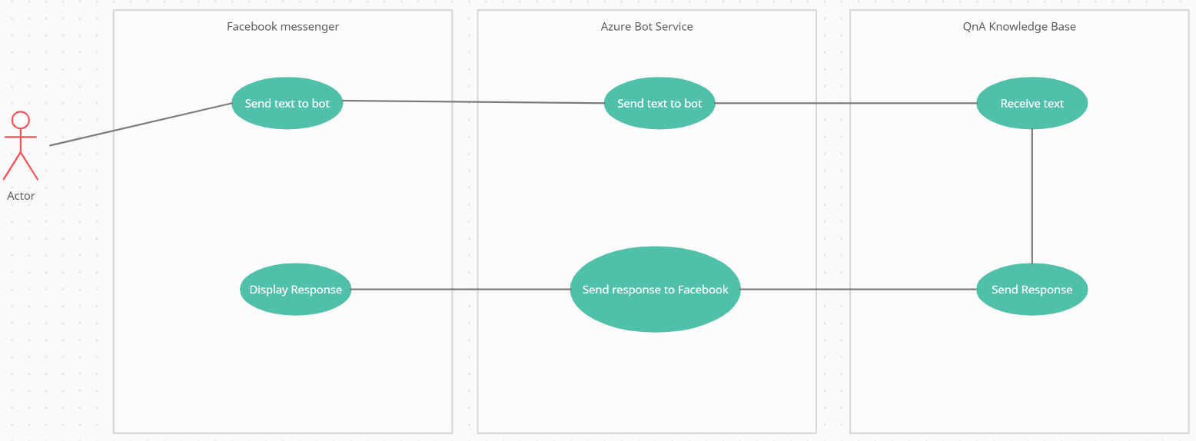

Figure 5 - high level use case

## 4.2 Analysing the hypothesis

From analysing the hypothesis with NLA some Key functional requirements became apparent. These Key requirements were expanded upon and more requirements were gathered.

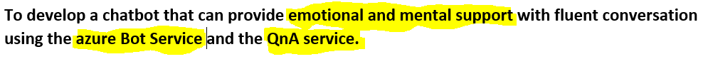

## 4.3 Prototype requirements

After analysing the high-level use case and combining it with the implementation phase 1 research objective. Two separate implementation phases were to be executed, with the first stage being the prototype. The prototype was to handle the basic setup of the chatbot and ensure that the project had a base to expand from.

## 4.4 Phase 2 Requirements

The phase 2 requirements were more involved with the interactivity of the chatbot in the form of implementing NLP tools and connecting through Facebook for a seamless connection to the chatbot.

## 4.5 Questionnaire requirements

From analysing the research objective “obtain a focus group”. It became apparent that requirements for the questionnaire should also be found and must reflect the key requirements set out by the hypothesis. This was because the effectiveness of the project was evaluated on a questionnaire sent to a focus group.

### **4.6** Ethical requirements

“commence user testing” Because of the nature of this project it was important to ensure that strict ethical requirements were both set and met.

## 4.7 Further Functionality

Once the objectives mentioned in the previous sections were established as sections that needed requirements to be met for the project and some basic requirements were resourced. The individual sections were then expanded upon to determine what exactly the sections requirements fully needed.

From brainstorming it also became apparent that the chatbot will be able to fetch weather information, log into Gmail accounts and give emotional support.

In addition, the questionnaire itself needed to be ethical and support the hypothesis/research question.

The requirements were also categorised as this would aid in the creation of the use cases later in the project for testing purposes. The requirements were separated into the categories:

**Normal:** This would be a regular requirement that would have a normal action.

**Unlikely:** This would be a requirement that would not likely be handled however should still result in a normal reaction.

**Validation:** This would be a requirement that would need exception handling i.e a user prompt.

The full requirements split into the various sections are available in Appendix A.

## 5 Design

As mentioned earlier in this report, the chatbot was being created in two separate phases. The Design stage of the project also includes Phase 1 and Phase 2. The two main components, relating to design were. The architectural design, or how the different systems interact with each other. The second was the functional design. This meant how the actual functionality of the chatbot would work.

The questionnaire design was also important to consider for this project as it was the main source of comparison to weather or not the chatbot meets the hypothesis of this project. The questionnaire was designed with ethical consideration at the fore front because of the sensitive nature of mental health.

## 5.1 Phase 1

Phase one focused on mainly getting the chat bot “up and running”. As mentioned in the research objective 3, the basic functionality would be created. In this case the basic design for the interaction between the systems and basic functionality was modelled.

### 5.1.1 Architecture Design

The requirements for phase 1 state that the chatbot must connect and communicate with azure. The basic architecture for phase 1 meant that the chatbot would have to be designed accordingly.

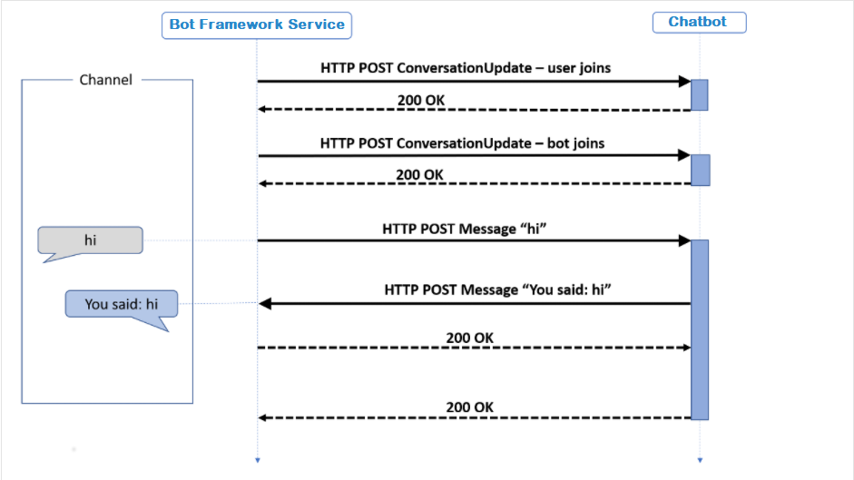

Figure - Phase 1 Architecture

Figure 6 further shows the design of the architecture of phase 1. It shows how the .net framework application, or the chatbot. Sends data between the device it is running on and the azure framework using Http. This shows how the chatbot would connect and communicate to Azure.

### 5.1.2 Functionality Design

The functionality was designed with the phase 1 requirements set out in the previous section. The phase one functions were to simply take the users input as a text format. Then echo back the input as the bot’s response. The chatbot was also designed to greet the user with a greeting message”

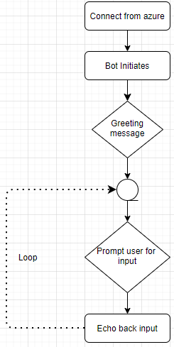

Figure -Phase 1 flowchart

Figure 7 shows the designed conversation flow for phase 1. It depicts how it creates a connection to azure in order to initiate the chat bot. Then once it has initiated, it then greets the user with a short message. The bot at this point will also display a list. Note if any of the list items, displayed as “cards” at this point. The chatbot should accept this input as the user’s text input. The cards are there so the author can observe the use of cards also at this point.

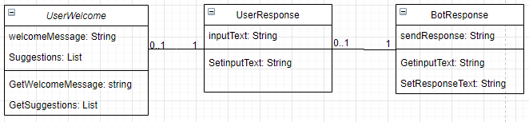

Figure -Phase 1 class diagram

Figure 8 displays more detail to the phase 1 design and shows the classes with the appropriate attributes. The above figure also shows the relationship to the classes. These designed classes meet the requirements set out in the earlier Phase 1.

The previous models show how the design requirements of “connect to azure” and the “Basic Communication” have been designed.

## 5.2 Phase 2

The design of Phase 2 aimed to meet the requirements that were associated with the more advanced functionality of the project. Like the phase 1 architecture and functionality design, Phase 2 also had These designs. The difference being that this Phase design was more complex and involved the more advanced functionality design.

### 5.2.1Architecture Design

The Phase 2 architecture is much more complex than phase 1. The Architecture in this phase was designed to meet the functional requirement “connect to QnA”

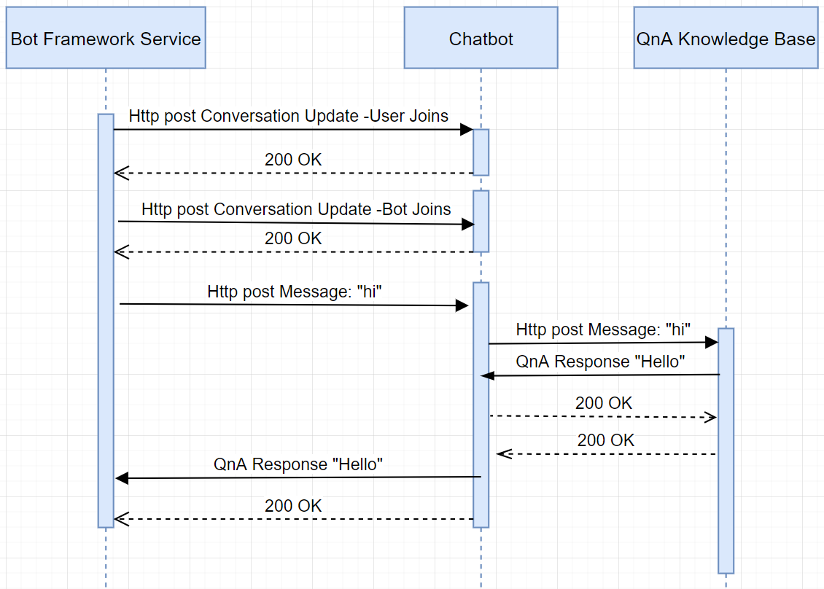

Figure - Phase 2 architecture

Figure 9 depicts firstly the user and chatbot joining the bot framework and receiving the POST response of 200. This means that the User and chatbot have connected successfully. After the user sends a message in the form of a POST request, The chatbot is designed to send this data to QnA which will parse the Text and try to find an appropriate response to the users input.

As can be seen in Figure 9 The chatbot sends this message to the QnA knowledge base. Once the data is sent to the knowledge base, the knowledge base is scanned looking for a matching response to the text “hi”.

Next it can be seen that the QnA knowledge base did have an appropriate response to the message. This “answer” is then sent back to the chatbot which then sends it back to the user that is currently logged into the bot framework service.

### 5.2.2 Functionality Design

The phase 2 Functionality focuses on designing the “Further Functionality” category established in the previous Requirements stage. This section includes a description on the final Class Diagram and talks about all the other functional requirements. Describing how they are designed along with conversation flows that have been designed to further compliment the coverage of the design meeting the appropriate requirements.

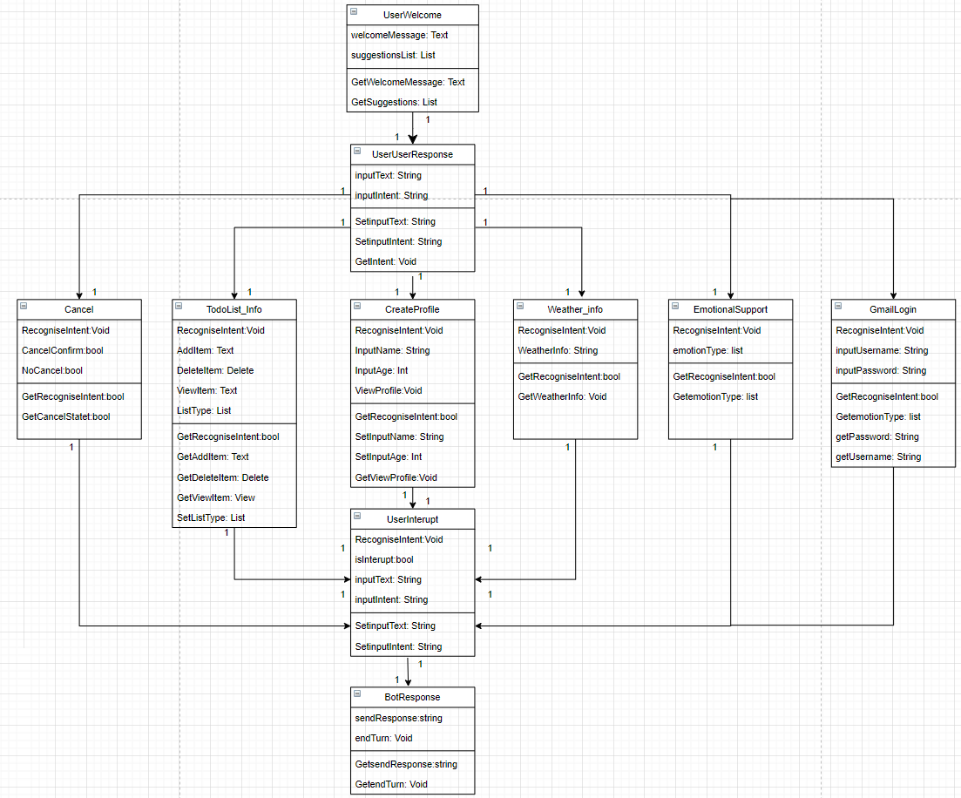

Figure - Phase 2 Class Diagram

Figure 10 Shows the final Class Diagram. This diagram was created to help provide evidence of design for the “further Requirements” category. Its focus is to show the relationships between the main classes that are to be implemented later in the project. The above diagram also shows the proposed classes and attributes that may be used in the implementation stage. As this is only a design the actual implementation may not follow this design exactly. However, It will be implemented to this design as closely as possible.

### 5.2.3 Conversation Flows

As part of the Design for phase 2, the author thought it necessary to also design the Conversation Flows for the “Further Requirements” Category in the requirements section. The conversation flow design are to show what path the chatbot takes to execute the function. These conversation flows were useful for the implementation of the requirements.

### Gmail

Logging into the users Gmail account was the first function that was designed. As can be seen below in figure 11 The user firstly connects to the Azure service which then initiates the bot. The user is then met with a greeting message and prompted to ask the bot something. As a note, these steps mentioned occur in all the next functions. So as to not repeat information unnecessarily, the information just mentioned will only occur in this paragraph. The before mentioned conversation flow phases will be referred to as “The main phases”.

After The main phases have been executed the bot will firstly connect to QnA. After which if QnA recognises that the user wants to “log in to Gmail”. QnA will send a request to the chatbot telling it to send a confirmation message to the user. After which the chatbot will then navigate the user to the appropriate login page for Gmail accounts.

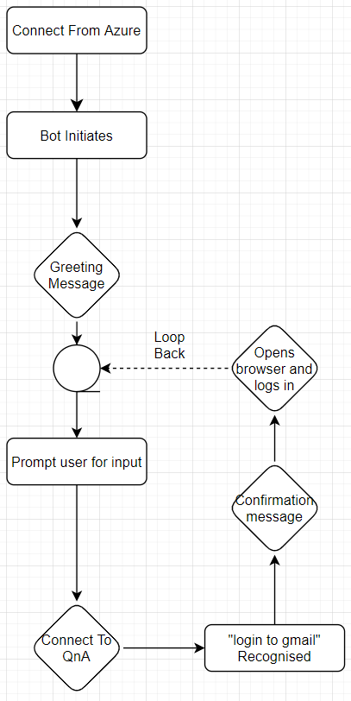

Figure - Gmail Convoflow

### Emotion Support

The chatbot was required to provide emotional support to the user if need be. The conversation flow below in figure 12 shows how this function was designed. After the main phases were carried out the chatbot was designed to “listen” for specific emotional phrases. Such as “I’m feeling sad”. If the chatbot analysed the data sent by the user and discovered a phrase that mentions an emotion. It would send the request to QnA which would check its database for a response to the appropriate emotion.

For example, if the user were to signal a negative emotion such as sadness. The QnA knowledge base is designed to try to support the user emotionally by sending an emotionally supportive response to the chatbot and in turn, the user. Conversely, if the user were to show a positive emotion such as “I’m happy”. The QnA knowledge base would check for the appropriate response to affirm the users positive emotion.

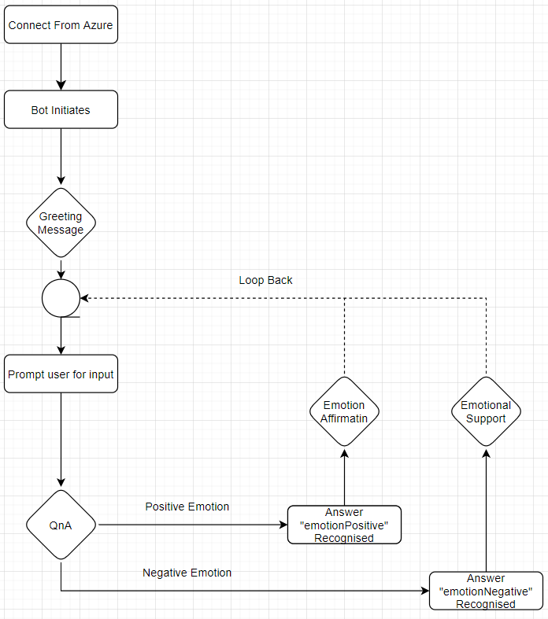

Figure - Emotion support Convoflow

### Weather Info

The weather requirement was designed to fetch the weather for the local area that the user was in. This would create a clickable URL that would allow the user to view the local weather forecast. Figure 13 shows how the user would trigger the QnA trigger “getWeather” the chatbot would then confirm that it would fetch the weather data. After which the clickable URL would become available. Once clicked on the user would be taken to an online service that displays local weather information.

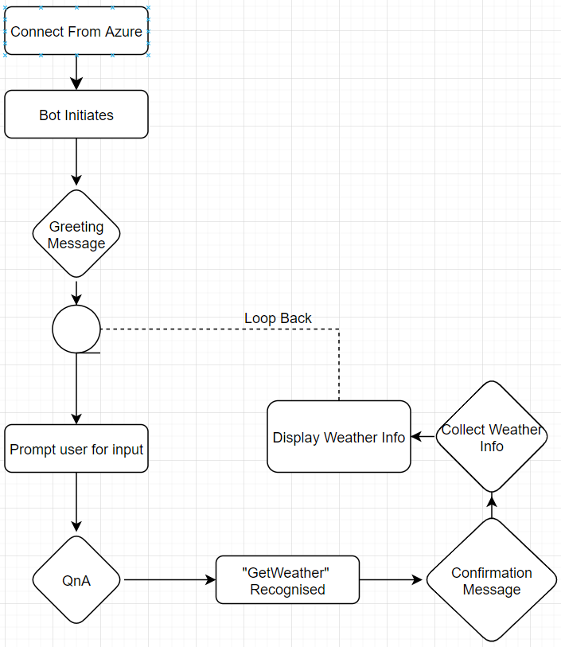

Figure 3 - Weather Info Convoflow

### 5.2.4 Questionnaire Design

The questionnaire that was to be used for the evaluation of the efficiency of the app was designed to be as ethical as possible. This meant that the questions that were to be designed had to be free of emotion and professionalism was used in the design of the question contents.

The author used Microsoft Forms to Design the questionnaire. Microsoft forms was able to also implement and test the questionnaire. However only the design phase will be discussed at this stage.

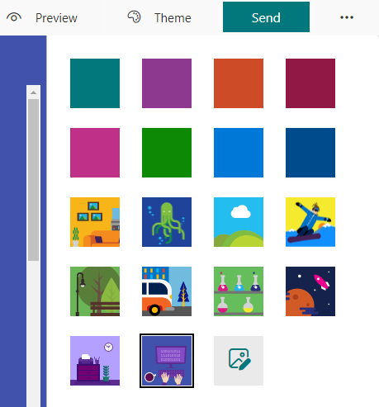

Figure 14 - Theme selection for Questionnaire

Figure 14 Shows the Theme Selection for the Questionnaire. One of these themes was selected and became the design for the theme of the questionnaire. Another useful function of Microsoft forms is that it allows questions to be sorted by drag and drop feature. The questionnaire was designed to have various response types to try and keep the user “interested” in the questions being asked. The input choices include rating scale questions. Multiple choice, selection and text entry.

A disclaimer before the user starts the questionnaire was also designed to be implemented to help with the requirement “questionnaire must be ethical”.

### 5.2.5 User interface Design

The user interface did not require any design as the final chatbot will be using the Facebook messenger application as the User Interface. This meaning that the user interface is already available as the chatbot “plugs in” to messenger.

# 6 Implementation

The implementation was split up into two main phases, Phase 1 and Phase 2. In these phases there are more smaller functions that are implemented within. The phase 1 implement focused on connecting the bot to azure and getting a basic response back from the bot.

The Phase 2 implementation was more focused on connecting the chatbot to the QnA Knowledge base. Once that had been implemented then the further functionality stage was implemented. This was the stage where the final functional requirements were met.

After which the Facebook implementation is detailed. This section describes how the chatbot was implemented onto the messenger application, ready for the bot to go “live”.

Finally, the questionnaire implementation is described showing how the questionnaire was created and administered to the focus group.

## 6.1 Phase 1 implement

Phase 1 implementation covers the connection to azure and the creation of the Prototype from which the full bot was created.

### 6.1.1 Connect to azure

The first and possibly main function that was to be created was the chatbot being created with azure. Azure served as the service provider for the connection to NLP tools and to Facebook in the Phase 2 implementation.

Figure14 Shows the use of the Azure bot service. This was used to ensure that the bot would come with the appropriate settings to enable it to be connected to azure.

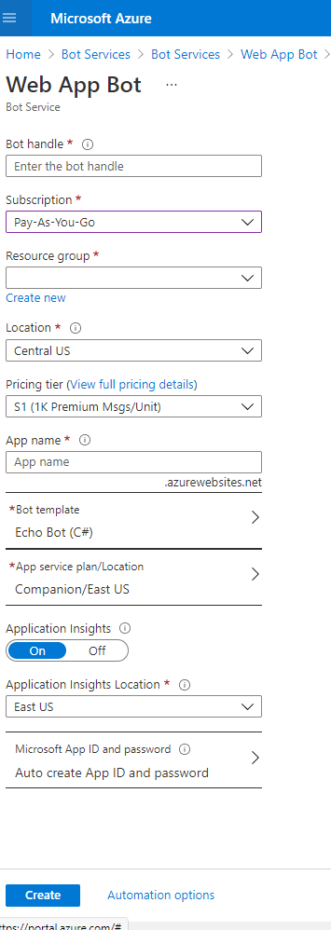

Figure -web app bot wizard

Figure15 Is the main control panel of the resultant template bot. This bot was used as a level to expand upon.

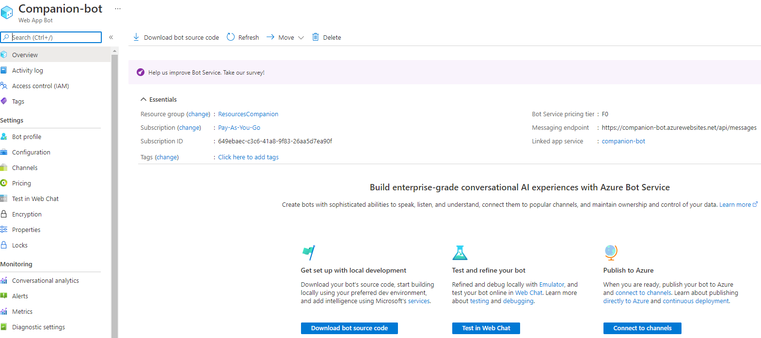

Figure - azure dashboard

The below screenshot figure 16 shows the settings file for the bot that enables it to be published to azure.

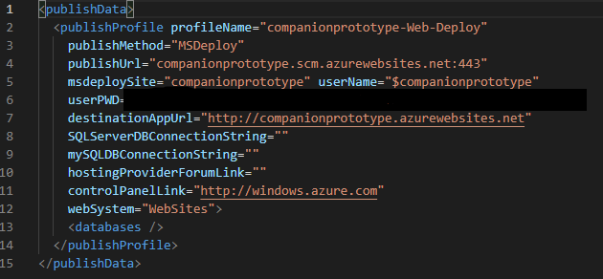

Figure - publish to azure code

### 6.1.2 Basic communication

The source code was then downloaded and inspected to further understand how the bot was implemented. Below is a screenshot of the logic of the bot itself. As can be seen the bot uses the built in “Echo function on line 13”. This takes in the user’s text and essentially sends it back to the user. The welcome message can also be seen on line 21. Figure 17.

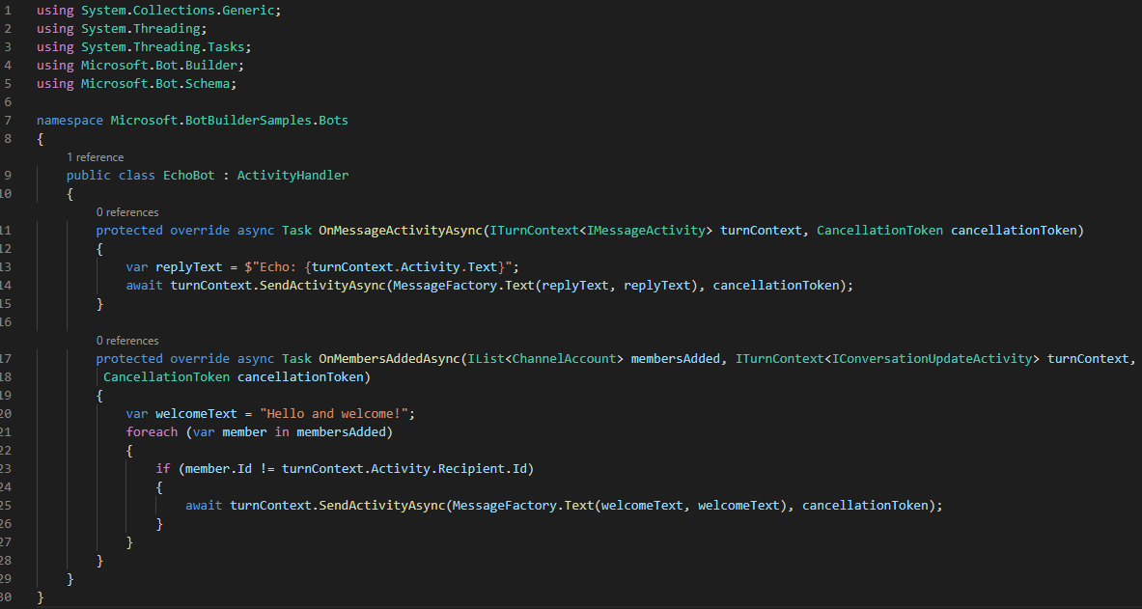

Figure - Echo Function

## 6.2 Phase 2 implement

The phase 2 implementation focuses on connecting the bot to QnA and the implementation of the Knowledge base is described. After which the further functionality Is then documented.

### 6.2.1 Connect to QnA

The below figure 18 shows how the QnA wizard was used to select the resource that was built on azure. After which the QnA knowledge base was created.

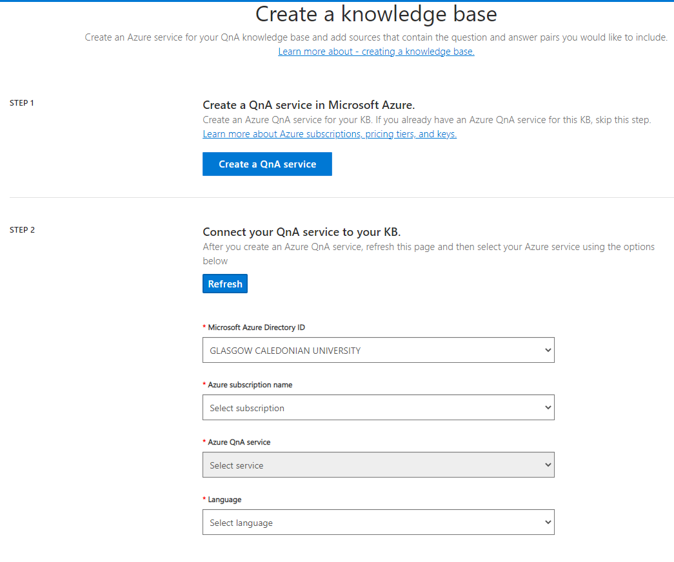

Figure - KB creation

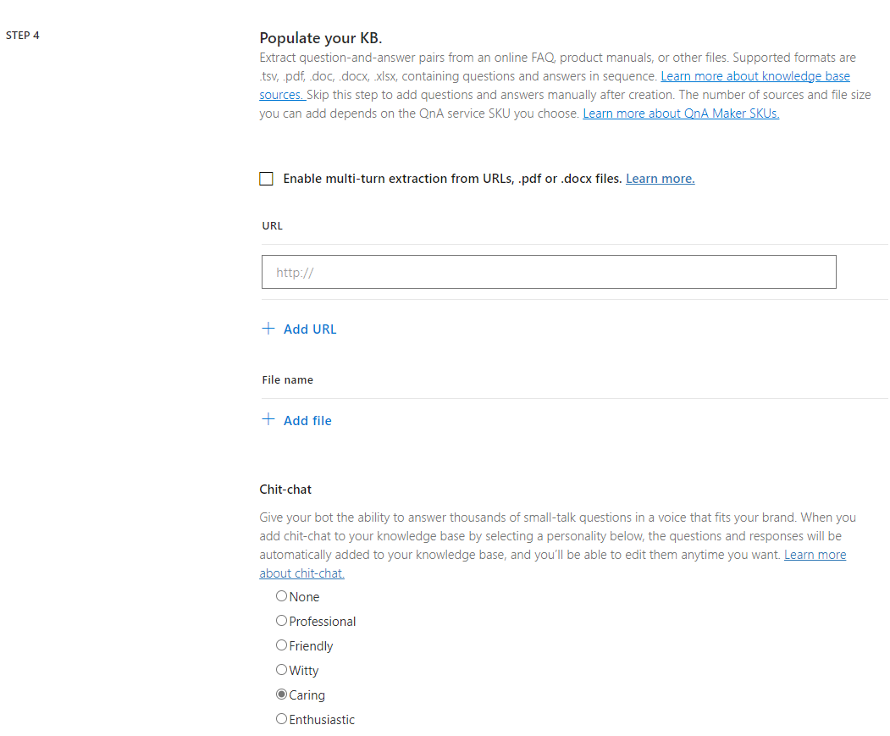

Figure - caring emotion

Figure19 Shows how the “emotion” that the chatbot would have was created. After the knowledge base was created. The knowledge base was then trained and published for the chat bot to access.

The below figure 20 shows the implementation of the various sources that were used. The functionality document is an edited file that controls the further functionality of the chatbot. The file is structured with headings as conversation flows. That will take different paths as the user says different things.

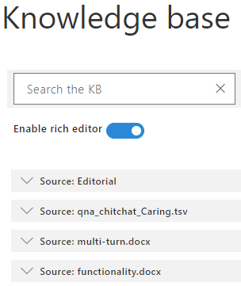

Figure - KB sources

In the below figure 21. The training of the knowledge bas can be seen in progress. As can be seen in the figure. The negative emotion response is being trained.

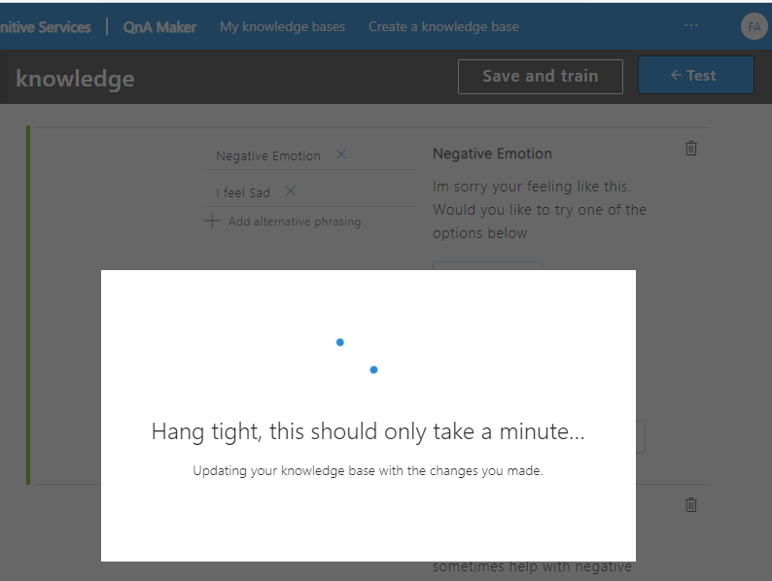

Figure - Training the KB

Here we can see in figure 22 The newly trained emotion response in action. The user has input “I feel ”sad” and the chatbot has offered an emotional reaction and offers ways to the user that may help the negative emotion. Once the user has chosen an option the chatbot then offers information on the type of help that is available and then shows an appropriate URL that will take the user to the chosen method of emotional support.

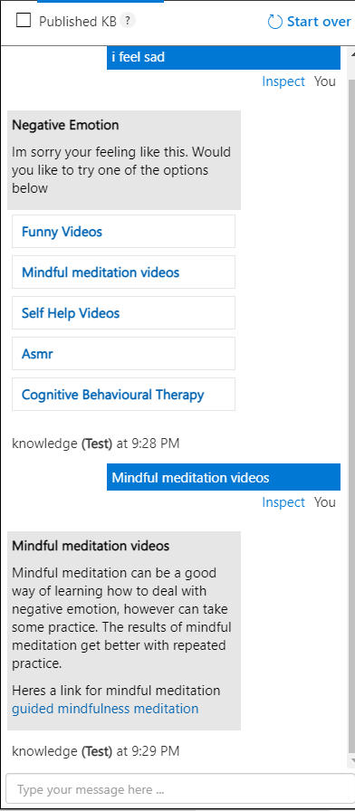

Figure - initial KB test

The QnA settings connect to the bot with a unique code that is generated upon implementation of the Knowledge base. This code is used to connect the bot to the QnA knowledge base. The below Figure24 Shows the json file that allows the QnA kb to connect to the chatbot.

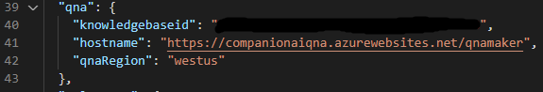

Figure - QnA connection Code

## 6.2.3 Further Functionality

This section details the implementation of the further functionality requirements. To keep from this section expanding to much into the word count. The further functionality of the chatbot was designed in a word document with specific headings to separate out different triggers. The link to the file will be included in a github repository which can be found in Appendix B.

Figure 24 Below shows support of negative emotional assistance being implemented. On the far left the layout of the negative emotion bot response can be seen. This was created by making a word document with the appropriate heading types. The middle section shows some of the phrases that the user may say. More will be added and the far right shows the trigger that would occur if the user was to say those “middle” phrases. As can be seen in the far right. The user is greeted with a calming response and a selection of different methods designed to combat negative emotions.

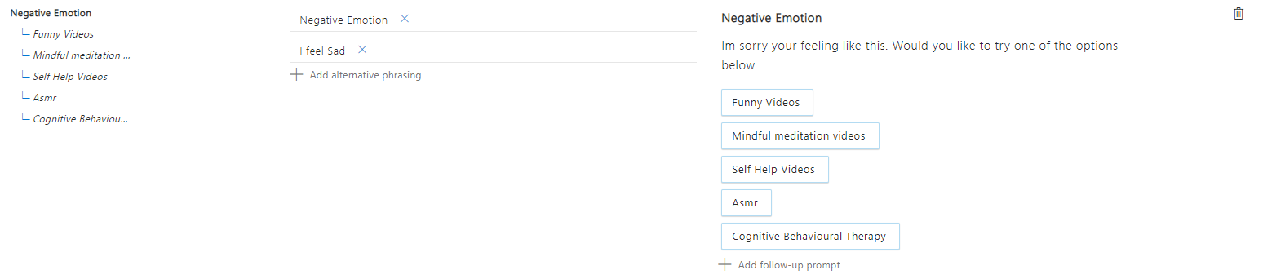

Figure - negative emotion trigger

The below figure 25 Continues the previous figures functionality. Below is shown what would happen if the user was to select the “Funny Videos” card from the previous response. The figure shows that on the far right that the user will be shown information on what that category has and a URL that will link the user to some funny videos. Note that this function could also be called specifically by the user entering the “middle” phrase. More will also be added. The far left just shows that it is indeed part of the negative emotion response.

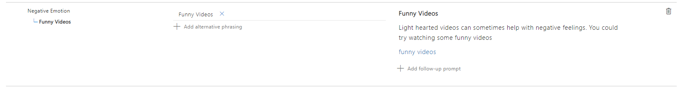

Figure - Funny video trigger

## 6.3 Facebook Implementation

Once the main functionality had been completed, the next step was to connect the chatbot to Facebook. This involved the implementation of a Facebook page to which the chatbot could use as a “channel”

After creating a Facebook page, Facebook Developer was used to then link the Facebook page to the chatbot, figure 26 Shows this.

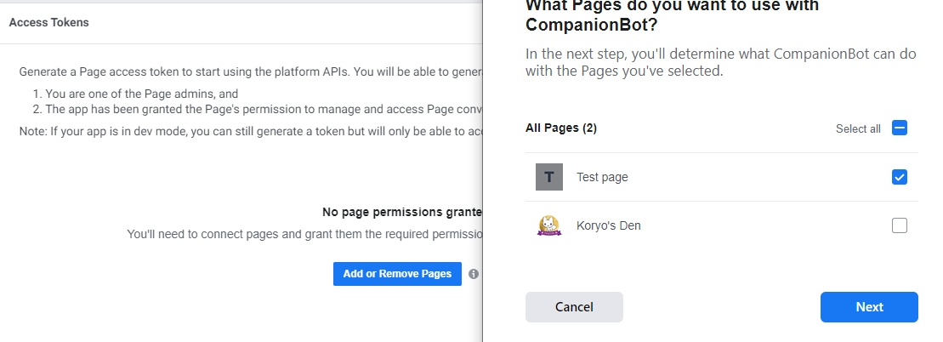

Figure - page link to app

Once the page had been linked the various app secrets, keys and endpoint URLs were collected Figure 27 And Figure 28

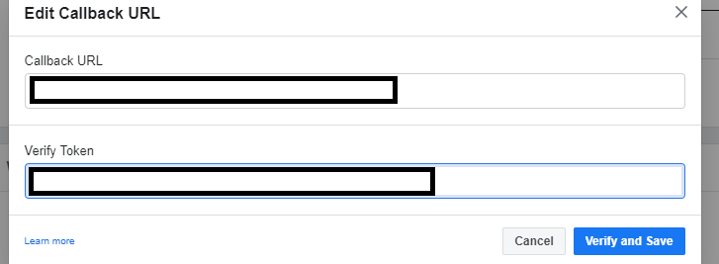

Figure – Verify token

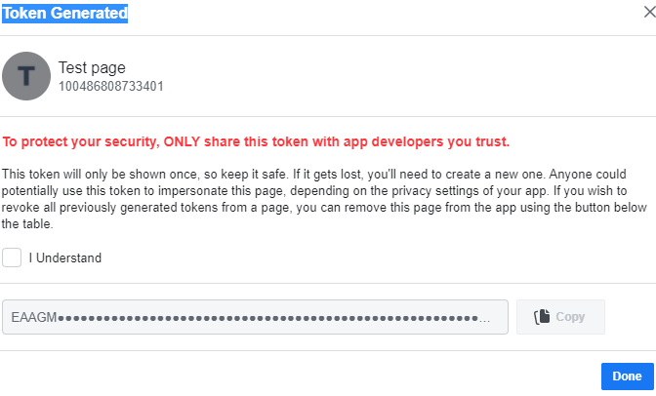

Figure - token

The Facebook app was then altered to allow API calls. This is how the chatbot sends and receives the requests in Figure 29

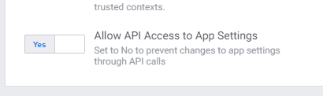

Figure - allowing API

The testers that would be present in the Facebook implementation were then added to the Facebook application. Figure 30

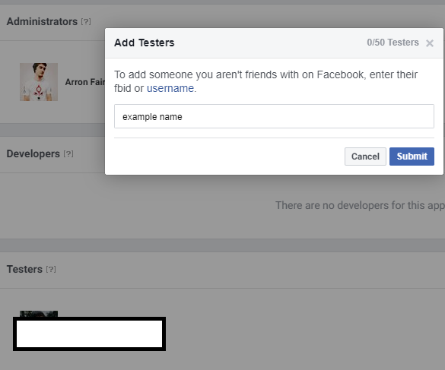

Figure - adding testers

After the testers were added the Facebook application was then connected to the Azure service for the chatbot to connect through Figure 31 Shows the keys and ID’s being used to connect.

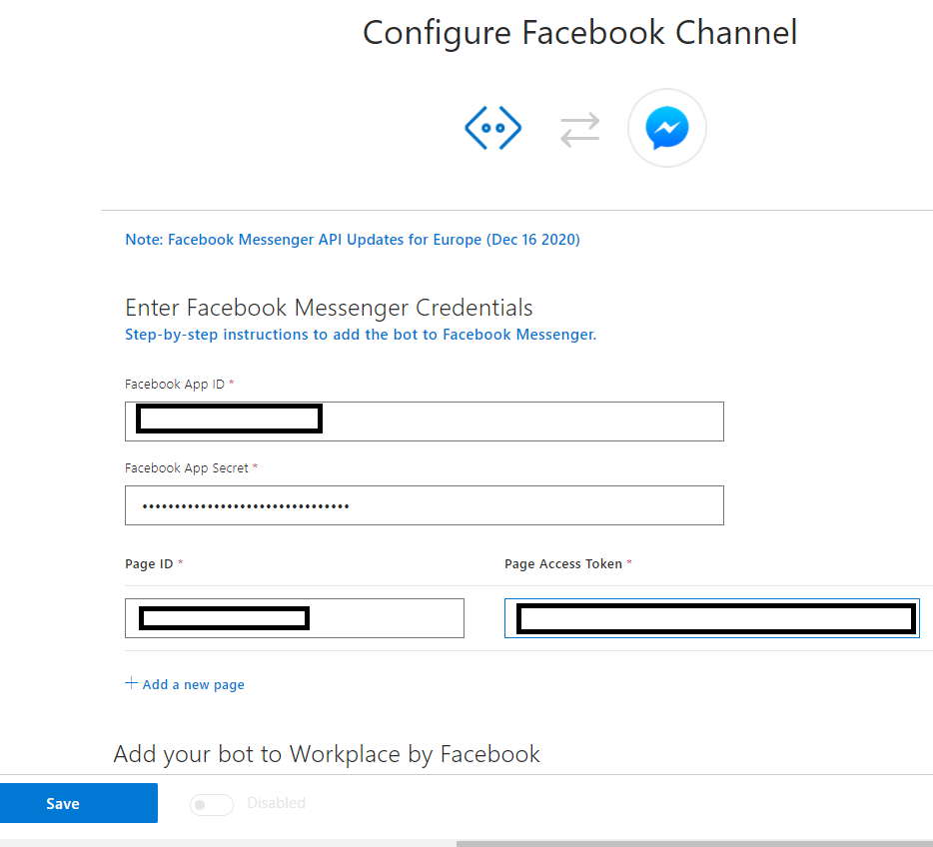

Figure - Linking to AZURE

And the success message as follows in Figure 32

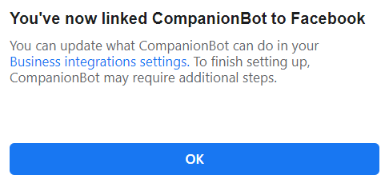

Figure - connection complete

## 6.4 Questionnaire implement

The questionnaire was implemented bearing the main aim of the project in mind. The below figure (figure 33) show the creation of a questionnaire section. These sections were used to help categorise the questions more and include a disclaimer to the tester.



Figure - creating question section

Figure 34 Shows Questions being added into the section. Note there were other types of questions added. However, they were added in the same manner as below.

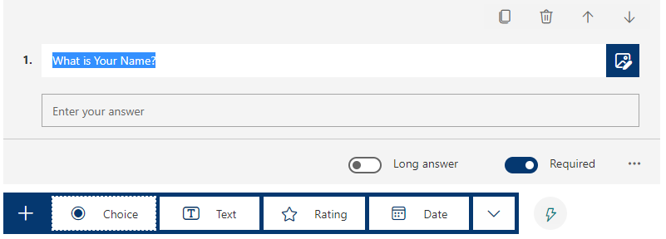

Figure - Adding Questions

Figure 35 Shows an implemented Section of the questionnaire. This will contain questions that refer to the users personal information.

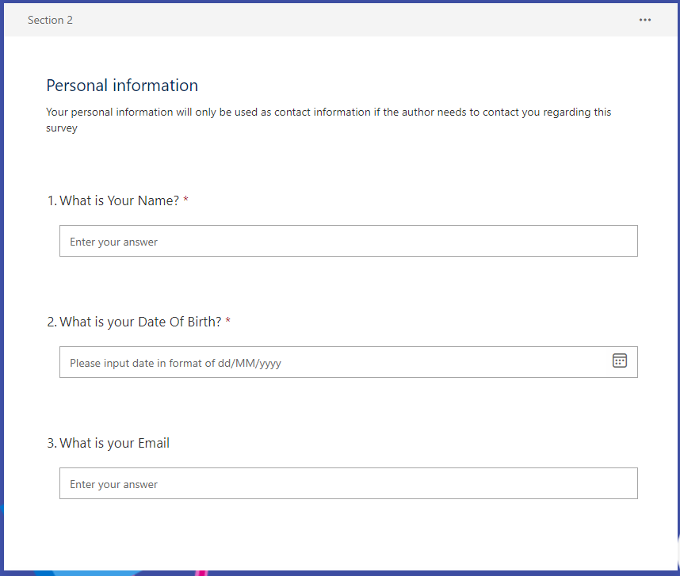

Figure - Completed Section

Figure 36 Shows a preview of one of the sections in the implemented questionnaire.

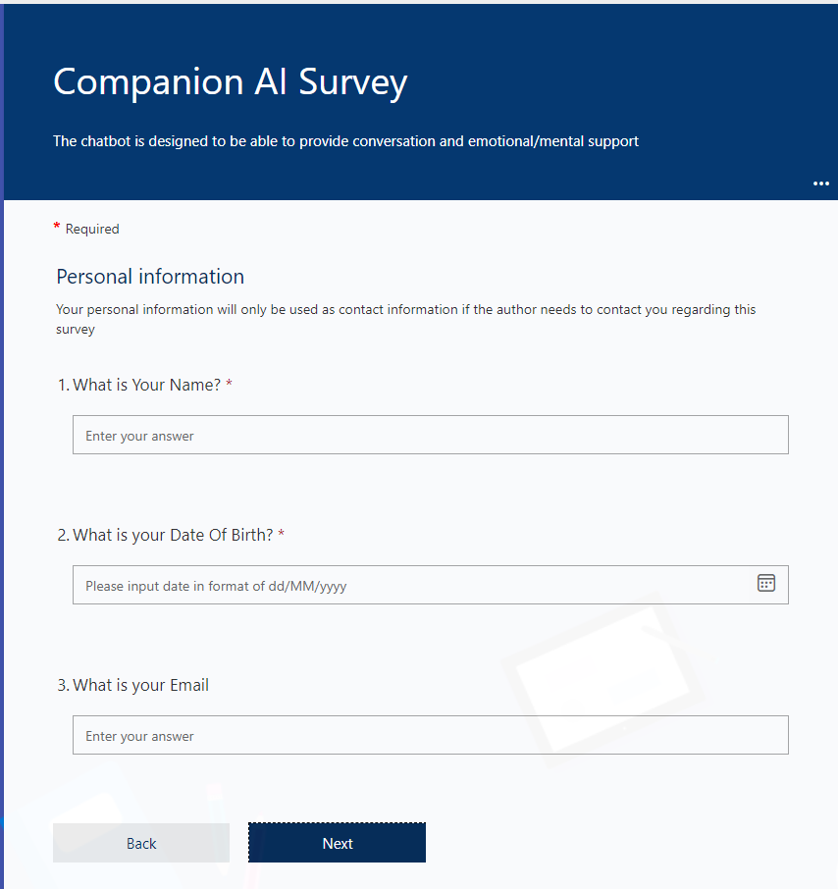

Figure - Preview

Using the send function of forms allows a reusable link to be sent to the focus group for live testing of the completed chatbot. (figure 37)

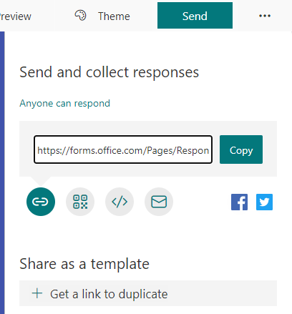

Figure - Share Link

# 7 Testing

The testing stage consists of testing the phase 1 and 2 implementation. The test results are in the form of tables and are designed to have an ID so the test can be related to the result figure. A description stating what the test objective was. An expected outcome and the actual response. Appropriate figures are also attached to the bottom of each main testing section

## 7.1 Phase 1 Test

|  |  |  |  |  |
| --- | --- | --- | --- | --- |
| **TestID** | **Description** | **Expected** | **Input** | **Actual Result** |
| 1 | The chatbot must be able to connect to azure | Upon loading the chatbot will be connected to azure | N/A | The chatbot can run in web chat through azure |
| 1.1 | The chatbot must run on .net framework in order to connect with azure | The chatbot will load successfully | N/A | Chatbot threads run fine on .net |

### 7.1.1 Test ID 1

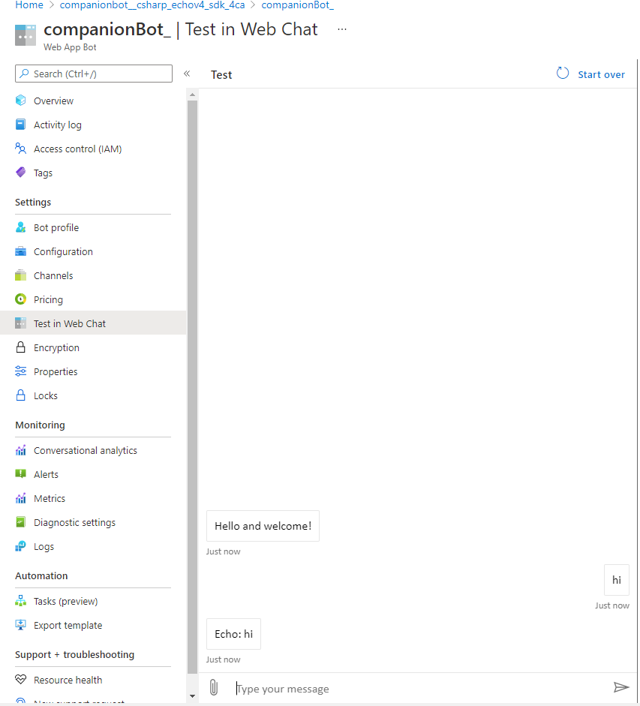

Figure - Test ID 1

### 7.1.2 Test ID 1.1

Figure - Test ID 1.1

### 7.2 Basic communication

|  |  |  |  |  |
| --- | --- | --- | --- | --- |
| **TestID** | **Description** | **Expected** | **Input** | **Actual Result** |
| 2 | The chatbot must accept text input from the user | Upon entering text, the chatbot will respond |  | Chatbot accepts text input |
| 2.2 | Must give introduction to chatbot | Upon loading the chatbot must show a welcome screen | N/A | Upon loading the chatbot shows a welcome message |
| 2.3 | The chatbot must use “cards” to signal other dialogues | Upon loading the chatbot will offer clickable cards | N/A | Upon loading the chatbot shows clickable cards |
| 2.4 | The chatbot will echo back the users input to show response was initiated | The entered text will echo back to the user |  | Chatbot echoes back text input |

### 7.2.1 Test ID 2 and 2.4

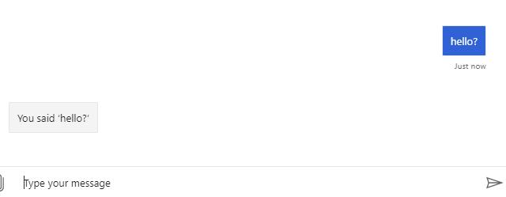

Figure - Test ID 2, 2.4

### 7.2.2 Test ID 2.2 and 2.3

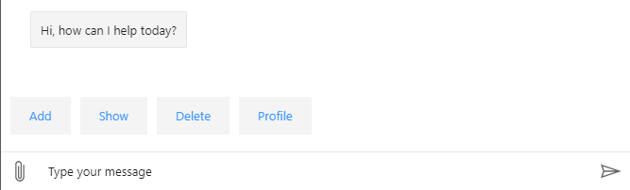

Figure - Test ID 2.2, 2.3

## 7.3 Phase 2 test

|  |  |  |  |  |
| --- | --- | --- | --- | --- |
| **TestID** | **Description** | **Expected** | **Input** | **Actual Result** |
| 3 | Chatbot must connect to QnA | The chatbot should be able to connect to the QnA KB | N/A | Chatbot responds with a QnA response, showing connection. |

### 7.3.1 Test Id 3

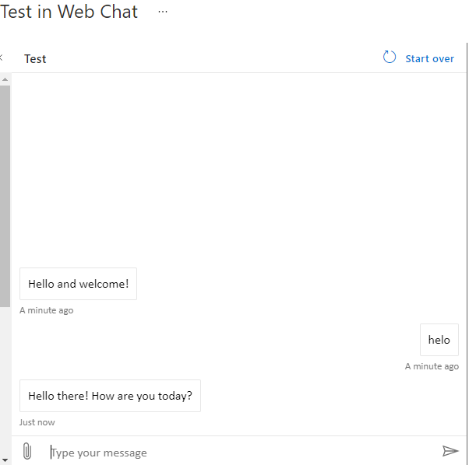

Figure - Test ID 3

### 7.4 Further Functionality

|  |  |  |  |  |
| --- | --- | --- | --- | --- |
| **TestID** | **Description** | **Expected** | **Input** | **Actual Result** |
| 4 | Chatbot will be able to log in user to Gmail | The chatbot will respond with message and supply URL to login | Text- “Log me into Gmail Please” | The user is provided a link that when clicked, is taken to gmail login. If the users password and username is cached, automatic login occurs. |
| 4.1 | Chatbot will be able to provide emotional support | Chatbot will be able to notice negative emotion and offer appropriate response | Text- “I Feel sad” | The user is provided multiple coping methods that link to the appropriate response. |
| 4.2 | Chatbot will enforce positive emotion | Chatbot will be able to notice positive emotion and affirm user | Text-“I Feel great!” | The users positive emotion is encouraged. |
| 4.3 | Chatbot can provide weather information for local | Chatbot will supply the user with local weather information | Text-“What’s the weather like?” | The bot responds with a link that shows the users local weather details |

### Test ID 4

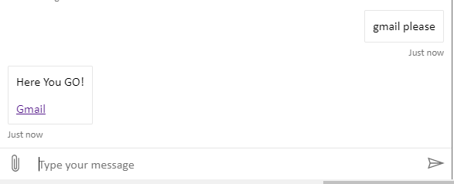

Figure - Test ID 4

### Test ID 4.1

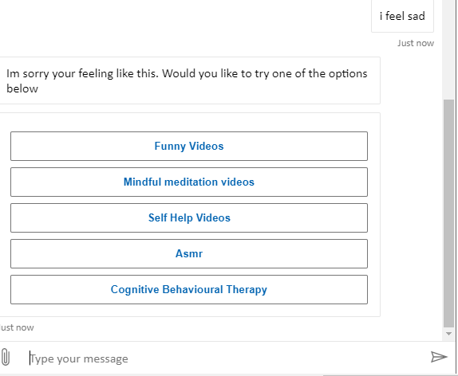

Figure - Test ID 4.1

### Test ID 4.2

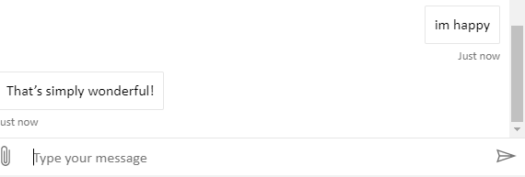

Figure - Test ID 4.2

### Test ID 4.3

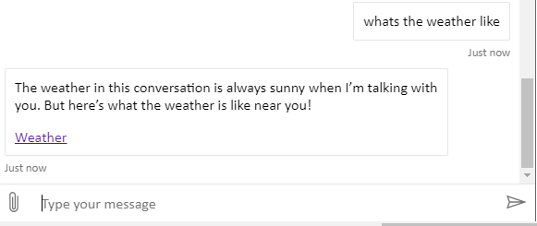

Figure - Test ID 4.3

## 7.5 Facebook test

|  |  |  |  |  |
| --- | --- | --- | --- | --- |
| 5 | Chat bot must connect to Facebook | Chatbot will be able to connect to Facebook | N/A | Upon entering text into Facebook messenger. The bot responds through it. |

### Test Id 5

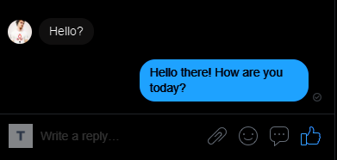

Figure - Test ID 5

## 7.6 User test (questionnaire)

The user test questionnaire results were collected using Microsoft forms. The results were compiled in the form of an exel file. The test results will be uploaded in the Github repository files with the heading Questionnaire results. The link for the repository can be found in appendix B or

click here [Questionnaire Results](https://github.com/afairley2/Honors-Project/blob/main/Companion%20AI%20Survey(1-5).xlsx).

From carrying out the questionnaire, averages were created with 5 being the highest an 0 the lowest score and are available to view in the below figure??

|  |  |
| --- | --- |
| Question Title | Average |
| How well do you think the Bot can handle conversation? | 3 |
| How well do you think the Bot offers emotional support? | 4 |
| What do you think about the overall functionality of the bot? | 3.4 |

Some pie charts were also created to further show the spread of the questionnaire results. Below Figure 48 shows that the focus group thought that the conversation flows were User friendly meaning that the chatbot was easy enough to use and interact with.

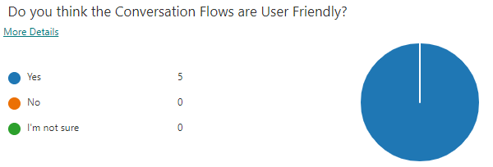

Figure - conversation question

Figure 49 below shows the focus group’s response to the question asking what could be further implemented to increase the users experience. Most of the focus group were stating that the chatbot could benefit from more complex conversation. This suggests that the chatbots responses to the user were perhaps to basic and could be improved upon.

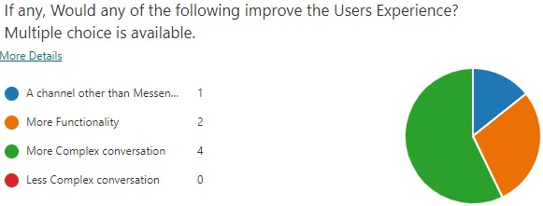

Figure - User Experience question

Figure 50 shows the response that the focus group gave to the question asking what audience they thought the chatbot was designed to target. As can be seen, most people felt that the chatbot was aimed to target users that were having emotional or mental issues. This is a good result for the project as this was one of its main aims and the focus group is backing this functionality.

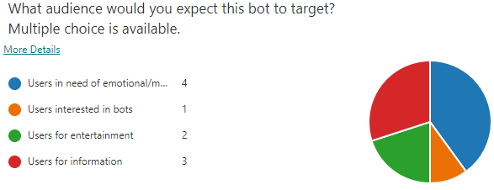

Figure - audience question

# 8 Evaluation/Discussion

The evaluation and discussion section focuses on analysing the development method that was used in the project. Discussing what phases of the method were used and if they were effective in the implementation of the project. This section will also analyse the test results that were shown in the previous stage and describe them in more detail. After the results of the tests have been evaluated. A discussion will then be carried out on the effectiveness of the chatbot relating to the hypothesis. Which is:

The created chatbot will be able to have conversation with the user and provide emotional and mental support.

## 8.1 Phase 1 Evaluation

The main aim of phase 1 was to be able to create a basic prototype that would be able to echo back the users input as text. The prototype was designed to be able to run on the Azure service with the .net framework. The purpose of the prototype was to test the basic functionality of the bot to analyse the usefulness of the Azure service.

The phase 1 testing results show that the prototype does indeed connect to azure and run on the .net framework. The basic communication testing also demonstrates the Bot echoing back the user’s input. This means that the phase 1 implementation was successful in meeting the requirements that were set out.

## 8.2 Phase 2 Evaluation

The phase 2 of the implementation was designed to be able to connect the chat bot to the QnA service and also to implement the further functionality of the chatbot. After the functionality of the chatbot was completed. It was then connected to Facebook messenger as a last step. This was to ensure that the users could reach the chatbot easily and through a service that the user was likely to be familiar with.

The previous phase 2 testing results show the chatbot successfully connecting to the QnA service. The further testing also confirms that the further functionality that was implemented, followed the requirements that were designed earlier in the project.

The testing executed on the connection to Facebook also shows the chatbot successfully using messenger as a channel for the chatbot to communicate with the user.

## 8.3 Questionnaire Evaluation

The questionnaire was designed to establish to what extent the focus group found various aspects of the chatbot. They were given a series of questions to answer that varied on different aspects of the chatbot. Once the focus group had answered the questionnaire an average was taken from the answers with 0 being the lowest and 5 the highest. One of the questions which was “How well do you think the Bot can handle conversation” had a rating that was 3 out of 5. This shows that most of the testers found that the bot could handle conversation on a normal level. Another question “How well do you think the Bot offers emotional support” had a 4 out of 5 average. This shows that the users in general thought that the chatbot handled emotional support very well. The overall responses of the focus group were positive.

## 8.4 Hypothesis Evaluation

The Hypothesis of the project was as follows:

The created chatbot will be able to have conversation with the user and provide emotional and mental support.

This hypothesis was evaluated against the previous testing and user testing. From the previous evaluations the author feels like the project does indeed meet the hypothesis in the project.

## 8.5 Agile Evaluation

Seeing as the project was a develop and test type project the agile methodology was used. This allowed with the implementation of the project to have multiple design implement and testing phases. This is one of the main functionalities of using the Agile methodology. The Methodology would be carried on into the further work if more work were to be executed on this project in the future. So not only was this methodology useful for the present creation of the project, but it would also be useful for any future work as it allows multiple iterations of the project.

## 9 Ethical and Professional Issues

The main ethical issue in the project was the nature of which the project was designed to target. Because the project focused on helping people that may be going through a tough time in their life and their mental state may not be so good. The project had to be designed in such a way that would not further harm a user’s mental health. Therefore, the requirements set out in the design stage were created with the user’s mental health in mind. During the implementation stage the QnA kB was set to “caring” this was also an attempt to make the chat bot as encouraging to talk to as is possible without making the user feel like the chatbot is being “condescending”. By using the requirements that were designed earlier in the project. They were then taken to the implementation stage. This was to ensure that the ethical requirements were implemented into the project.

Another form of ethical consideration was in the creation of the questionnaire. Seeing as the questionnaire was to ask the users about mental health and the support that the chatbot gave. The questions had to be designed in a way that meant that the user would not feel pressured in any way. Therefore, in the disclaimer section of the questionnaire it states that the user does not have to answer it if they do not want to. Or feel like the questionnaire may be to much for the user to answer. The user is also assured that only the author would see the users name and email address. Also, in the disclaimer it states that the user would only be emailed if the author found an issue with the users test results and that would be the only reason the user would be contacted in this case.

# 10 Conclusions

This section includes the project resume before making final conclusions on the project as a whole. Discussing the effectiveness of the project meeting the project aim and hypothesis. After this the Further work that could be considered for the project are then described in detail.

## 10.1 Project Resume

This project was designed to help people that may be having a difficult time in their lives. Or needing someone to talk to. The chatbot was designed to be easily accessible to the users by using Facebook messenger and to be able to handle conversation with the user. Another function of the chatbot was to be able to recognise a negative emotion and handle it in an appropriate way. Depending on the severity of the negative emotion the chatbot would act in different ways. For example, if the user were to say “I feel sad” the chatbot would offer some options in ways of coping with feeling sad. If the user said something like “my pet had died” then the chatbot offered grief counselling. However, if a strong negative emotion were recognised such as “suicide” the chatbot would urge the user to contact the suicide prevention team and provide phone numbers and their website.

Initially a literature and technology review was carried out in order to further realise the depth of creating a chatbot and the different types of chatbot that area available. From the literature review the main aim of the project was realised which is:

using a “develop and test” type methodology. Develop a chatbot that can provide emotional and mental support and then release it onto Facebook for a focus group to test and answer a questionnaire. From these results an evaluation will be carried out to test if the chatbot satisfies the problem.

This chatbot was created using the Agile methodology which allows for multiple iterations that were shown in this project. The analysis, design, implementation, testing, and evaluation stages were used in the iterations of the project to realise the final product.

## 10.2 Final Conclusion

The hypothesis of the project was:

The created chatbot will be able to have conversation with the user and provide emotional and mental support.

This section will discuss weather this hypothesis was realised or not and what could have been done differently in the project. As with any small-scale projects there would have been many ways to have realised this hypothesis and the main limitation with many projects was the lack of time in order to complete the project. The main issue in developing a chatbot is where to choose to stop expanding the functionality of the chatbot.

The hypothesis can be broken down into two main components. The chatbot needed to handle conversation with the user and Provide emotional and mental health support. The first component was realised through the connection to the QnA knowledge Base. The “caring emotion” (Figure 19 below)



Gave the chatbot the “chit Chat” functionality. This enabled the bot to understand the main conversation points that the user may ask the chatbot. The “chit Chat” source was then edited and other sources were created to further enable the conversation of the chatbot.

(Figure 20 below) shows all the sources that were created. Note that only the “Qna_chitchat_Careing.tsv” was created automatically and the other sources were created manually. These manually created sources were used to enable the chatbot to handle basic communication.



As the previous user testing section that was carried out shows Figure 51. The average response of the users show that they are generally happy with the conversational functionality of the chatbot. The author suggests that this is evidence of the chatbot meeting the “can the chatbot handle conversation with the user” requirement of the hypothesis.

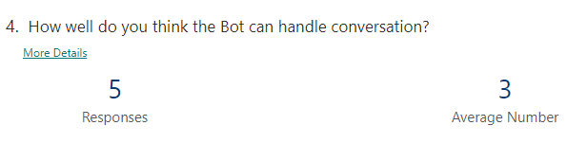

Figure - bot conversation responses

The second section of the hypothesis was, “can the chatbot provide emotional and mental health support?” This second section was realised by creating the other knowledge base sources that are available here for full viewing [QnA Knowledge bases](https://github.com/afairley2/Honors-Project/commit/d6e3d6262c9e4f3d04ac7229beff99870c6771a3).

The below figure shows the “functionality.docx” this was created to enable the recognition of a negative emotion and respond appropriately.



The test results “Test ID 4.1” further support that the recognition of a negative emotion is indeed noted and a response is provided by the chatbot. In the user testing the average score below figure 52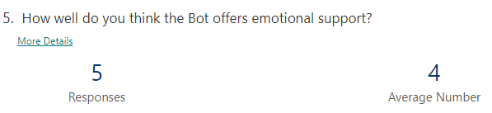

Figure - emotion supp result

Shows an average response of 4 which suggests a very good capability of the chatbot handling emotional support. With these results in mind, the author feels that the second section of the hypothesis was also met.

There was one section of the project that could have perhaps been improved upon. Figure 53 shows the focus groups response to the question asking what could be improved in the chatbot to improve user experience. This shows that the chatbot could have possibly would have benefit from more complex conversation. This could suggest that the responses that the chatbot was responding with were perhaps to basic.

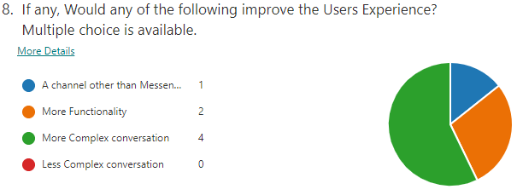

Figure - improve user exp question

As a note, more users would have been sourced but as the current covid19 situation. The means of sourcing a larger focus group were also limited in the project. The author of the project could not physically ask people to take part in the project. Therefore, the focus group was limited to contacts that the author had electronically.

Overall, the author feels like this project met the requirements and accomplishes the aim of the project as a collective.

## 10.3 Further work

Seeing as this project could be considered a “small scale” project, there is always room for addition to the original project. Some of the future work that could be carried out on this project could be as follows. The main reason the following features were not included in the project were for time management reasons and to make the project more manageable in general.

### Speech recognition

From the development of the chatbot it became apparent that it could have been a good idea to have more than just the input of text to interact with the chatbot. This is where speech recognition cold have been useful to the project as it could have made interaction with the chatbot more dynamic.

### Facial recognition

Perhaps a more advanced method of interacting with the chatbot further than only speech recognition could be the use of facial recognition. This meant that the chatbot could have been useful for both users that could not talk or type. This could have added another element into the project as disabled access for the project which could have been another functional requirement.

### Improve triggers

The triggers that the chatbot used to determine what the user was intending to communicate could be further fine tuned to increase the overall accuracy of the chatbots responses. Some of the users stated that they had some difficulty with longer phrases and the bot could sometimes give “confused” responses. These issues could be tuned out with further development.

# 11 References

microsoft, 2019. *docs.microsoft.* [Online]   
Available at: https://docs.microsoft.com/en-us/azure/bot-service/bot-service-overview-introduction?view=azure-bot-service-4.0  
[Accessed 13 11 2020].

Microsoft, 2020. *docs.microsoft.* [Online]   
Available at: https://docs.microsoft.com/en-us/azure/bot-service/bot-builder-tutorial-deploy-basic-bot?view=azure-bot-service-4.0&tabs=csharp  
[Accessed 18 11 2020].

Pickell, D., 2019. *learn.g2.* [Online]   
Available at: https://learn.g2.com/chatbot  
[Accessed 27 02 2021].

# 12 Appendices

## Appendix A – Functional Requirements

The functional requirements had to be separated into sections to allow for simpler expansion on the larger functionalities of the chatbot. In essence the chatbot must be able to :

**Phase 1**

* **connect to Azure**
* **basic communication**

**Phase 2 must also be able to**

* **connect to QnA**
* **connect to Facebook**
* **further Functionality**

**The questionnaire will have its own requirements**

Each table will further expand on these larger requirements.

**Phase 1**

**connect to Azure**

|  |  |  |
| --- | --- | --- |
| **Name** | **Type** | **Description** |
| Must fetch chatbot data from Azure | Normal | The chatbot must be able to connect to azure |
| Chatbot must run on .net framework | Normal | The chatbot must run on .net framework in order to connect with azure |

**Basic communication**

|  |  |  |
| --- | --- | --- |
| **Name** | **Type** | **Description** |
| Must allow for input of text to chatbot | Normal | The chatbot must expect text input from the user |
| Must give introduction to chatbot | Normal | Upon loading the chatbot must show a welcome screen |
| Must offer clickable options to the user | Normal | The chatbot will use “cards” to signal other dialogues |
| The chatbot will respond back with user input | Normal | The chatbot will echo back the users input to show response was initiated |

**Phase 2**

**connect to QnA and Facebook**

|  |  |  |
| --- | --- | --- |
| **Name** | **Type** | **Description** |
| Connect to QnA | Normal | Chatbot must connect to QnA |
| Connect to Facebook | Normal | Chat bot must connect to Facebook |

**Further Functionality**

|  |  |  |
| --- | --- | --- |
| **Name** | **Type** | **Description** |
| Login to Gmail | Normal | Chatbot will be able to log in user to gmail |
| Emotional support | Normal | Chatbot will be able to provide emotional support |
| Fetch weather info | Normal | Chatbot can provide weather information for local |
| Data extraction | Normal | Chatbot can analyse a sentence and extract valuable key words to understand response needed |

**Questionnaire**

|  |  |  |
| --- | --- | --- |
| **Name** | **Type** | **Description** |
| Is it ethical | Normal | The questionnaire must be ethical |
| Topic focus | Normal | The questionnaire must answer the hypothesis/Research question |

## Appendix B – Github repository

### QnA KBs

[QnA Knowledge bases](https://github.com/afairley2/Honors-Project/commit/d6e3d6262c9e4f3d04ac7229beff99870c6771a3)

### Source Code

[Source Code](https://github.com/afairley2/Honors-Project/commit/dc83f1c3232b53889d69456f623658bd3a872ca2)

### Questionnaire results

[Questionnaire Results](https://github.com/afairley2/Honors-Project/blob/main/Companion%20AI%20Survey(1-5).xlsx)